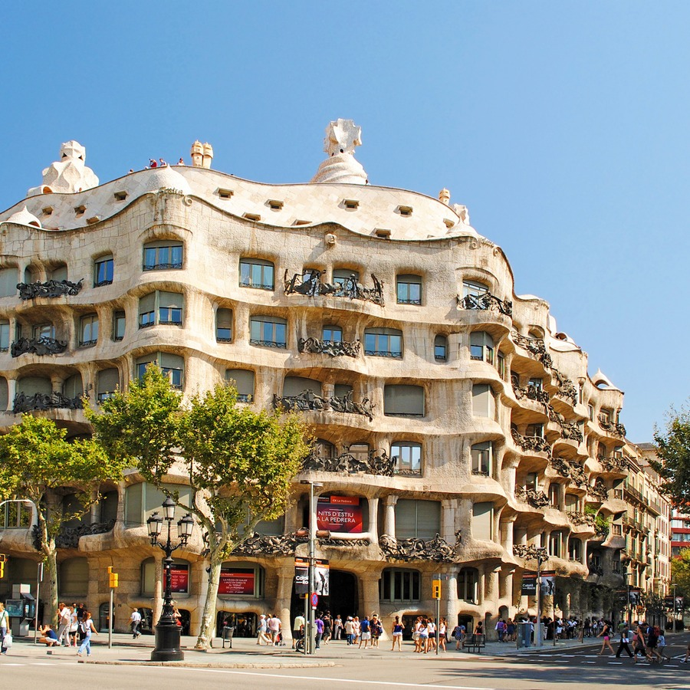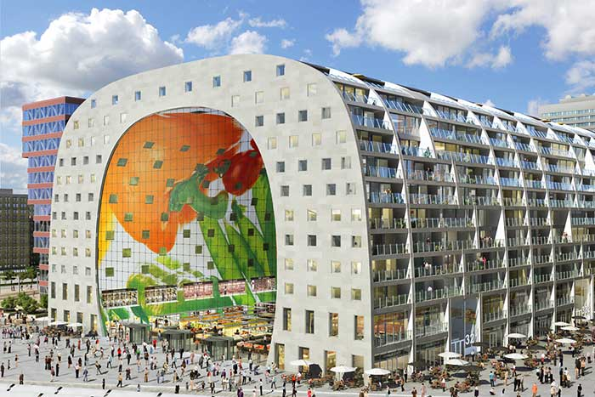

https://www.tiqets.com/nl/barcelona-c66342/casa-mil-la-pedrera-skip-the-line-p973460?gclid=CPyz0b_qhswCFUI_Gwod_ogCHw

https://nl.wikipedia.org/wiki/Markthal_(Rotterdam)

